**To:** Dr. Christopher Roberts and Dr. R Bertrum Diemer, Jr

**From:** Team T - Abdul Fayeed, Adarsh Kannan, Gavin Guerrera

**Date:** April 21st, 2022

**Subject:** Progress Report #3

**Abstract**

During progress review 2, the carbonylation route was preferred over the esterification route, based on economic analysis via the locus of critical investment curves, spreadsheet level balances, and reactor sizing and analysis. Thus, the next phase was to optimize our process flow diagram, including the recycle structure for methanol, and carbon monoxide, along with another round of sizing, equipment costing, VGA and NPC calculations. Another important objective during phase 3 was to determine the catalyst used for the dehydration reaction. The two choices were between the ion-exchange resin, which operates at around 100oC, and the H-mordenite catalyst, which operates in gas phase, and is pressure driven. Based on reactor design and kinetics, it was found that the amount of H-modernite required for a similar conversion is lower, compared to the ion-exchange resin. Despite the catalyst cost for ion-exchange resin outweighing the cost for the h-mordenite catalyst, the reactor size for the former was smaller than that for the latter, hence significantly saving on capital and equipment costs. Thus, based on these factors and the critical analysis done, it was decided to proceed with the ion-exchange resin. Finally, it was difficult to obtain a recycle stream for CO, due to the non-convergence of the ASPEN simulation caused by the accumulation of methane in the streams. Separation of methane from CO is an arduous task, with the cost of separation outweighing the benefit of having a recycle stream.

**Douglas’ First Method to Determine Batch vs Continuous**

This task was to determine whether the scaled up cumene process should be carried out via a batch or a continuous process. To determine this, the Douglas method was utilized. For processes whose annual production is less than 500 tons/yr, the batch process is preferred. On the other hand, if the production is greater than 5,000 tons/yr, the continuous process is preferred. As shown in **Appendix G**, the required production of methyl acetate is 170,097 tons/yr, which is greater than 5,000 tons/yr, hence determining that the continuous process is preferred in this scenario.

**Step 3 and 4 of Douglas’ Method**

**Figure 1** and **2** show the two recycle and separation structures in place for the MeOAc synthesis process. Figure 1 shows the separation structure for the first phase of the process, which includes the dehydration of methanol to form dimethyl ether (DME). This consists of a fired heater, which is connected to the first distillation column, which separates DME from methanol and water. The DME is sent in as fresh feed into the second phase of the reaction. Meanwhile, the methanol and water are fed into another heater and distillation column, which recycles the distillate methanol, and discards the unused water, which has about 3% impurity of methanol in it.

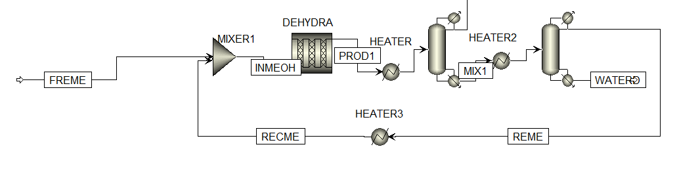

**Figure 1.** Recycle structures for MeOAc synthesis.

**Figure 2** shows the separation structure following the second reactor. First, the contents from the reactor are heated before a flash vaporization to separate the methane and carbon-monoxide. The remaining DME, MeOH and MeOAc are sent into a distillation column, where the bottoms product contains 99.99% wt purity. **It was desired to separate the carbon monoxide from the methane utilizing a flash tank. However, this separation is expensive, and the cost of separation outweighs adding a separate stream.**  Hence, it was decided to purge the excess carbon monoxide methanol stream.

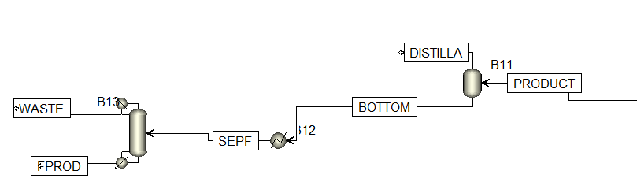

**Figure 2.** Separation structures for MeOAc synthesis.

**Process Flow Diagram (PFD)**

**Figure 3** and **4** depict the process flow diagrams (PFD) for the mordenite and ion-exchange resin catalyst respectively. The equipment utilized is similar, except for the reactor design procedure, which is explained in the next section. In the first case, a feed of 700 kmol/hr enters along with a recycled feed of 116.348 kmol/hr. This is compressed in the mixer to a pressure of 10 bar, where it enters an isothermal reactor which operates at 380oC and 24 bar. In case of the ion-exchange resin, the reactor operates at 90oC and 1 bar. The initial product feed then passes through a fired heater, which is then fed into a distillation column from which the distillate is fed into the second feed, and consists mostly of dimethyl ether(DME), and the bottoms consist of a mixture of methanol and water. This mixture is then fed into another heater followed by a distillation column which recycles the distillate stream consisting of methanol and the bottom stream consisting of water is discarded. Fresh carbon monoxide is added with the DME in a 100% stoichiometric excess. This is fed into the second reactor at 209oC and 15 bar. The product feed, consisting of methyl acetate (MeOAC), methane, hydrogen, DME and methanol is fed into a flash separator. The bottoms, consisting of methyl acetate and methanol are fed into another heater and distillation column, which then provides 99.99% purity MeOAc.

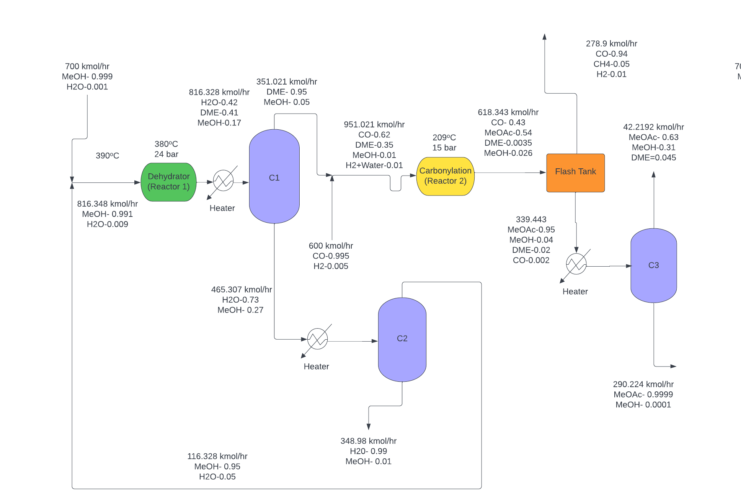  
**Figure 3.** PFD when utilizing H-mordenite catalysts on both reactors.

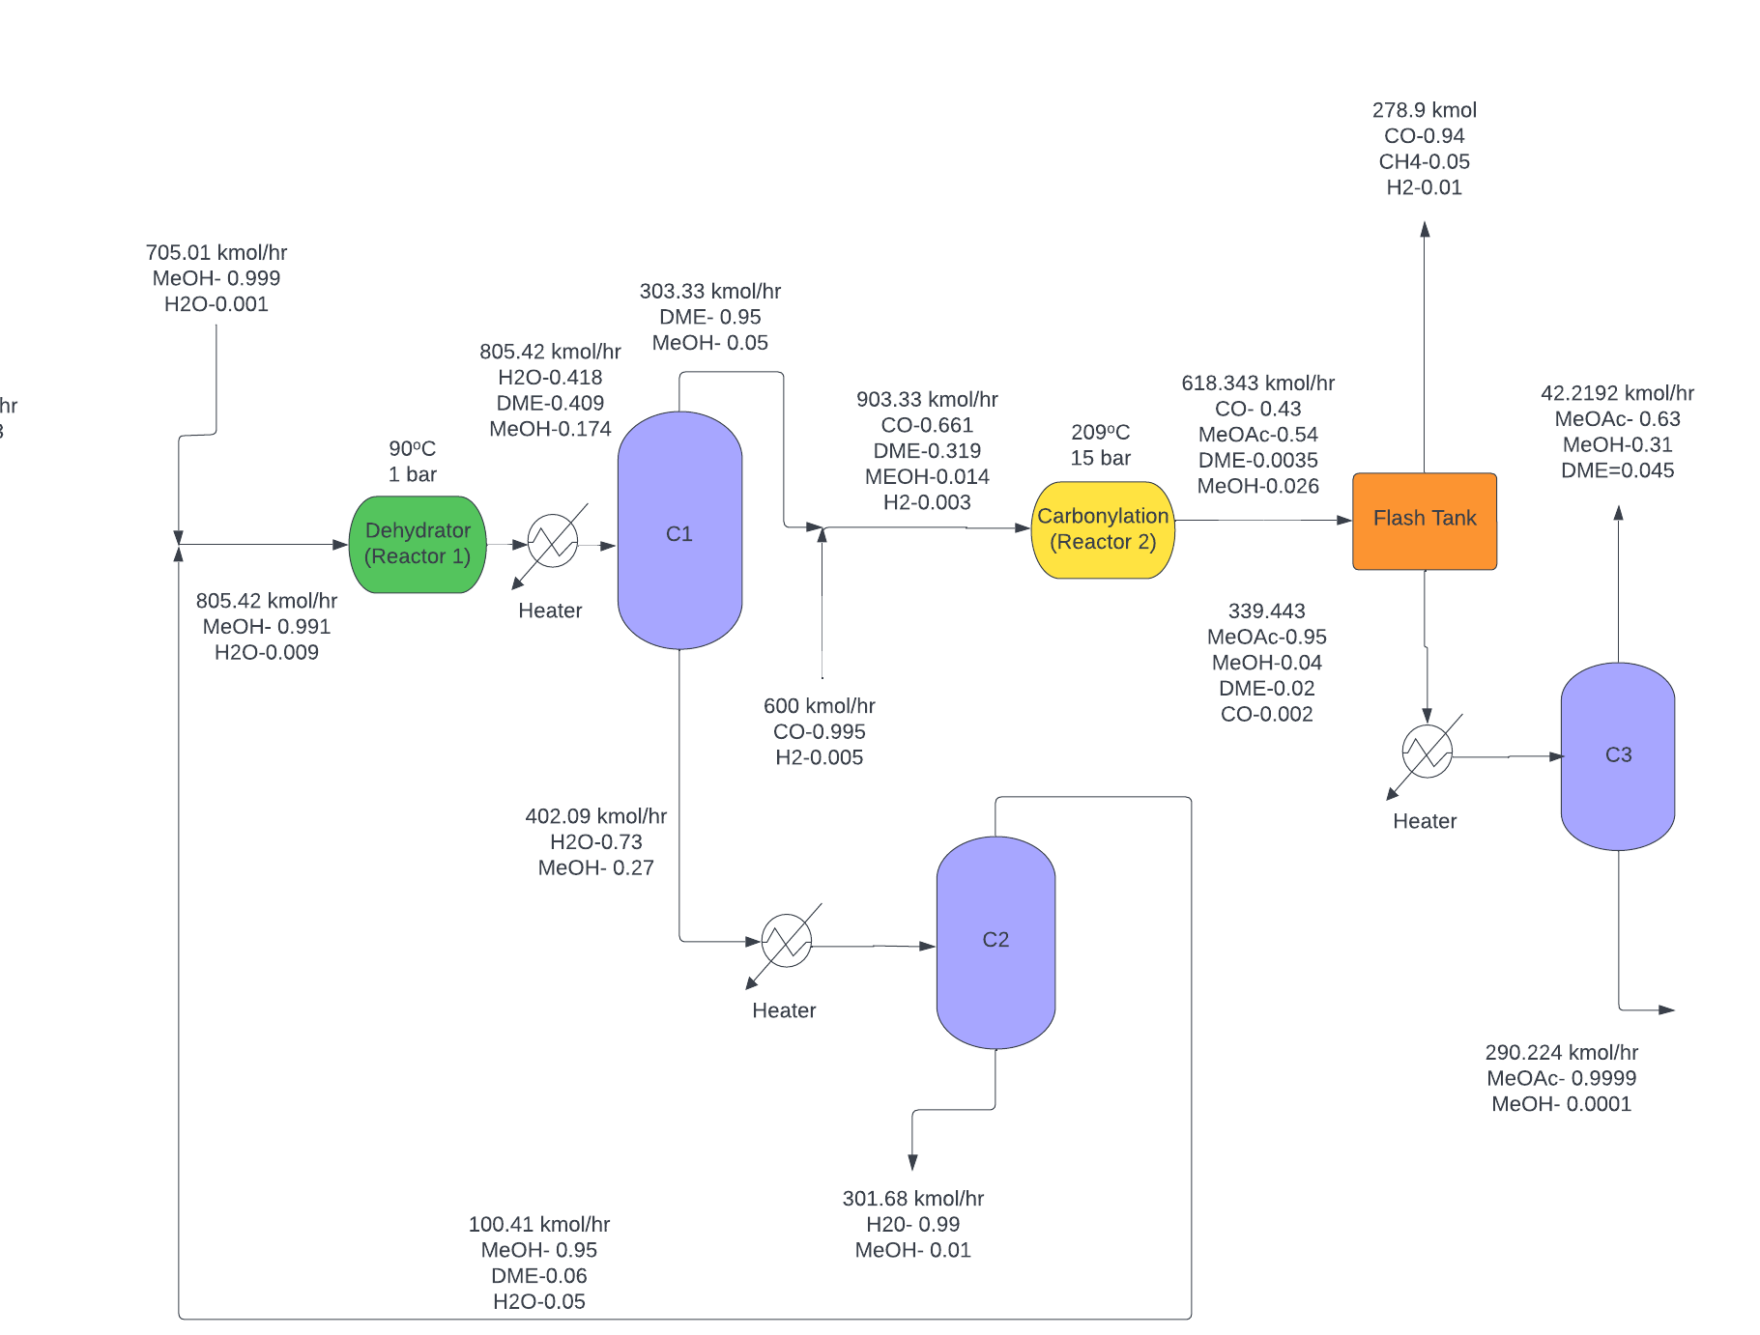  
**Figure 4.** PFD when utilizing ion-exchange resin and H-mordenite catalysts on the first and second reactor respectively..

**Reactor Design**

Based on the kinetics provided in the MeOAc paper , first, offline reactors were modeled on MATLAB. The plot for catalyst mass as a function of temperature for various conversion percentages are provided for both the ion-exchange and mordenite catalyst. From this, it is evident that the mass of the catalyst required in case of the ion-exchange resin is at least 10 times higher than that for the H-mordenite for similar temperature profiles. However, the cost of the latter is at least 10 times higher than the former, which leaves a delicate balance between both reactants. **Figure 5** and **6** show plots for mass and cost considerations for both catalysts respectively. Moreover, the higher bulk density of the ion-exchange catalyst implies higher catalyst and equipment cost. Finally, after obtaining a converged aspen simulation, the values of temperature and pressure were utilized to find the catalyst mass and the reactor volume, and this process was repeatedly carried out until a convergence was obtained.

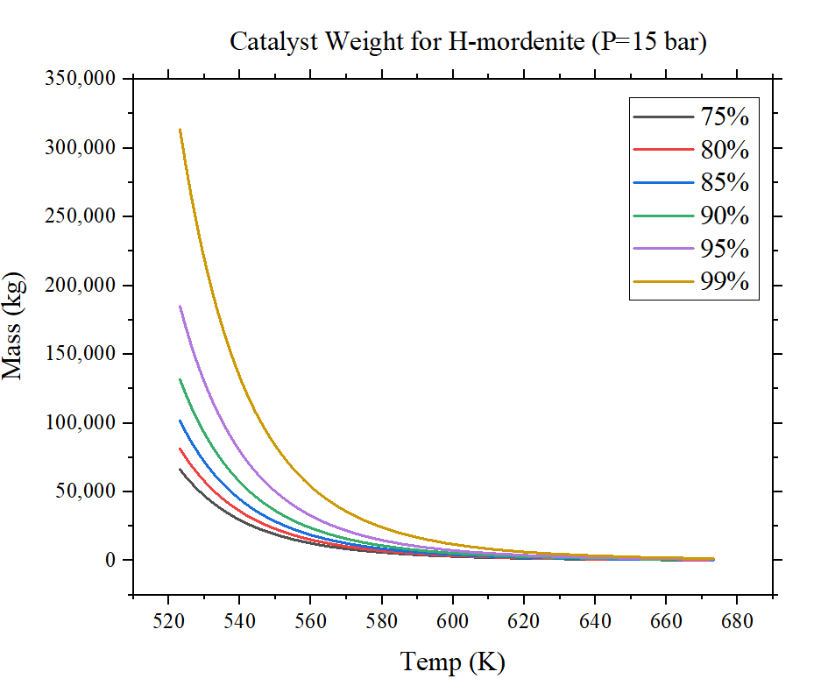

**Figure 5.** Changes in H-mordenite mass with respect to reactor temperature (P = 15 bar).

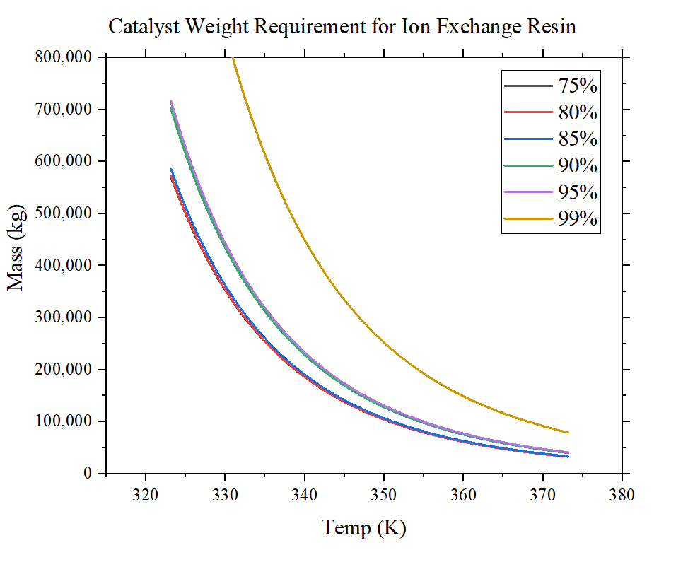

**Figure 6.** Changes in ion-exchange resin mass with respect to reactor temperature (P = 1 bar).

**Reactor Optimization**

The reactor specifications for the dehydrator and carbonylator can be seen in **Table 1** below. The first step of this optimization involved offline reactor modeling to find kinetic parameters and equilibrium constants. Also, preliminary catalysts masses were found using the bulk densities provided in the main assignment paper. These masses were used to determine the reactor volumes. 1 inch diameter pipes with a 0.5 inch gap between each pipe. With these values and **Eq. 1 - 3**, the reactor areas, number of tubes, and tube length were determined. These values were then inputted into aspen where further simulations optimized the values to what is seen below. For the dehydrator there was a choice between the ion-exchange resin catalyst and the H-mordenite catalyst. The H-mordenite catalyst required was 2,206 kg while the ion-exchange resin catalyst required was 67,995 kg. This led to a much larger reactor size for the resin scenario greatly increasing purchase costs. Also, the total catalyst cost was $154,372 for the mordenite catalyst while the resin catalyst was $333,175. With a cheaper reactor and total catalyst cost, the H-mordenite catalyst was selected. Finally, isothermal reactors were preferred over adiabatic reactors as they provided a better conversion for a similar reactor size.

**Table 1.** Dehydration and Carbonylation Reactor Specifications

| **Type of reactor** | Dehydration | Carbonylation |
| --- | --- | --- |
| **Catalyst Mass (kg)** | 2,206 | 60,000 |
| **Number of Tubes** | 1,850 | 15,400 |
| **Tube diameter (m)** | 0.0254 | 0.0254 |
| **Tube length (m)** | 5.64 | 16.38 |
| **Operating Temperature (oC)** | 380 | 209 |
| **Operating Pressure (bar)** | 24 | 15 |

$Area=(1+3s+3s^{2})πd_{t}^{}[3((2s+1)d_{t}+2(s+1)δ)]$**Eq. 1**

$Number of Tubes=(1+3s+3s^{2})$**Eq. 2**

$Bundle Diameter=(2s+1)d_{t}+2(s+1)δ)$& $\frac{Length}{Bundle Diameter}∼3$**Eq. 3**

**BOE Material Sizing**

The back of the envelope (BOE) method was utilized to size all units present in the process to produce methyl acetate (MeOAc). In total, 2 reactors, 3 columns, 4 heaters, 1 flash tank, 3 reboilers, 3 condensers, and 2 mixers were used for the carbonylation process.

Reactors, reboilers, heaters, and condensers were sized by assuming they were heat exchangers. **Appendix A** shows how to find the heat-exchange area by utilizing the heat duty and design flux in the exchanger. On top of that, the flash tank is sized by acquiring a diameter and height of the column, as shown in detail in **Appendix B**. Moreover, the sizing method for a distillation column is done with the number of stages priorly determined. **Table 2** summarizes the heat-exchange area for the equipment that were sized as heat exchangers.

**Table 2.** Heat-exchange area (ft2) comparison between two catalysts.

| **Catalysts** | H-mordenite | Ion exchange |
| --- | --- | --- |
| **Reactor 1** | 8,962 | 190,108 |
| **Reactor 2** | 216,704 | 216,704 |
| **Reboiler 1** | 3,377.05 | 2,936.16 |
| **Condenser 1** | 3,943.86 | 3,425.16 |
| **Reboiler 2** | 1,197.66 | 1,033.87 |
| **Condenser 2** | 1,110.20 | 959.50 |
| **Reboiler 3** | 1,108.20 | 2.48 |
| **Condenser 3** | 2,336.61 | 37.40 |

**Cost Analysis**

To determine the cost related to heat exchangers, it was essential to ascertain the type of heat exchanger required for the process. Thus, the change in inlet temperature, $ΔT_{in}$ was used as a measure. For < 50oC, the fixed heat heat exchanger was utilized, while for > 50oC, the floating head heat exchanger was utilized. Based on the areas calculated in sizing in **Appendix A**, the bare-module cost of the heat exchangers can be computed as shown in **Appendix C**.

To cost the distillation column, the diameters were first scaled based on the flow rates, and this is done as shown in **Appendix D**. To cost the flash tank, the diameter and length of the tank were found priorly as shown in **Appendix B**. **Appendix D** shows the detailed calculations to cost a distillation column and vertical pressure vessel (flash tank). Furthermore, **Appendix E** shows how to cost a compressor and fired heaters respectively. **Table 3** listed the comparison in bare-module costs for each equipment for both catalysts.

**Table 3.** Bare-module cost ($MM/yr) comparison between two catalysts.

| **Catalysts** | H-mordenite | Ion exchange |
| --- | --- | --- |
| **Reactor 1** | 0.24 | 8.10 |
| **Reactor 2** | 10.29 | 10.29 |
| **Reboiler 1** | 0.07 | 0.07 |
| **Condenser 1** | 0.08 | 0.07 |
| **Reboiler 2** | 0.04 | 0.04 |
| **Condenser 2** | 0.04 | 0.04 |
| **Reboiler 3** | 0.04 | 0.10 |
| **Condenser 3** | 0.06 | 0.03 |
| **Flash tank** | 0.09 | 0.28 |
| **Heater 1** | 1.70 | 0.33 |
| **Heater 2** | 0.18 | 0.16 |
| **Heater 3** | 0.35 | 0.32 |
| **Heater 4** | 1.21 | 0.07 |
| **Column 1** | 1.64 | 1.40 |
| **Column 2** | 0.96 | 0.86 |
| **Column 3** | 0.64 | 0.24 |
| **Total CBM** | 17.65 | 22.38 |

**Revised Economic Analysis**

**Table 4** provides the investment estimate (VGA), cost of manufacture (COM), transfer price at 25% net return of investment (NROI), internal rate of return (IRR), net present value (NPV), and net present cost (NPC) for both catalysts. The VGA for utilizing ion-exchange resin catalysts is approximately $13MM/yr higher than just H-mordenite catalysts. This should be the case as the cost to build the reactor that uses ion-exchange resin alone is about 40x more expensive than utilizing just H-mordenite ($8.10MM/yr as opposed to $0.24MM/yr). The cost of the rest of other equipment remains relatively the same from one another, or does not change by much relative to the reactors’ costs. Due to this, the COM for having ion-exchange resin is slightly higher, which is reasonable due to the additional utility required to employ the expensive reactor. The transfer price at 25% NROI is smaller for H-mordenite alone, although it does not differ significantly from the other option. The goal is to have the transfer price as low as we could, and the insignificant difference between the price alone couldn’t be a deciding factor of which catalysts to employ. The NPV is also very similar from one another, however, the NPC for H-mordenite is lower by $12MM/yr. With lower transfer price, NPV, and reactor costs, H-mordenite is chosen moving forward as the only catalyst used in both reactors.

**Table 4.** Revised economic analysis on both catalysts options.

| **Catalysts** | H-mordenite | Ion-exchange resin & H-mordenite |
| --- | --- | --- |
| **VGA ($MM/yr)** | 54 | 67 |
| **COM ($MM/yr)** | 183 | 198 |
| **Transfer Price @ 25% NROI ($/tonnes)** | **1,142** | **1,191** |
| **IRR (%)** | 27.36 | 27.36 |
| **NPV ($MM/yr)** | 4 | 5 |
| **NPC ($MM/yr)** | 305 | 317 |

**Conclusions**

After performing offline reactor simulations to obtain kinetic parameters, the reactor conditions and catalyst masses were determined. By comparing these values, the H-mordenite catalyst was chosen. The difference in VGA between the Ion-Exchange Resin and H-Mordenite is mostly due to the reactor cost. Also the H-mordenite system has a slightly smaller transfer price compared to the Ion-exchange resin indicating again that the mordenite is more profitable. The recycle structure proved to be difficult so an open-loop system was chosen for the time being. Further work will be optimizing the system as well as attempting to implement the recycle structure.

**Limitations**

One of the limitations in the model is that the recycle stream for carbon monoxide couldn't be realized in this process, due to the accumulation of methane in the system. ***Appendix I***details this issue, and it has been concluded that the cost of separation outweighs additional cost of carbon monoxide feed.

**Future Work** Now that the H-mordenite catalyst has been chosen as the optimal route, the next step is to further optimize the process, including the flows, reactor and separation structures. Another task is to try to find the cost of separation of carbon monoxide and methane, and try to perform a heat integration in order to save on utilities.

**Appendices**

***Appendix A: Determination of Heat Exchange Area***

**Table A.** Various values of heat flux

| **Type of flux** | **Flux value (BTU/hr/ft2)** |
| --- | --- |
| Gas-to-gas | 300 |
| Liquid-to-liquid | 8,000 |
| Phase change | 10,000 |
| Condensing steam | 12,000 |

To find a heat exchange area, the type of flux has to be determined first in order to use the appropriate heat flux value. Assume that it is a gas-to-gas flux with a heat transfer duty of *a* BTU/hr. The heat exchange area is determined as shown in **Eq. A**.

$Heat exchange area,A=\frac{a BTU/hr}{300 BTU/hr/ft^{2}}=\frac{a}{300}ft^{2}$**Eq. A**

***Appendix B: Determining the Length and Diameter of the Flash Tank***

To find the length and diameter of the flash tank, the flow rate into the tank has to be determined first. Let’s use an arbitrary number of 1,043.16 kmol/hr as the inflow rate. This flow rate is converted to m3/hr by considering the molar composition and density of the components in the inflow.

**Table B1.** Molar composition and thermodynamics properties for each component

| **Components, i** | **Molar composition, xi** | **Molar mass, MWi (g/mol)** | **Density, ρi (g/m3)** |
| --- | --- | --- | --- |
| Methanol | 0.0043 | 32.04 | 792,000 |
| Dimethyl ether | 0.0472 | 46.07 | 2,110 |
| Water | 0.0000 | 18.02 | 997,000 |
| Carbon monoxide | 0.5191 | 28.00 | 1,140 |
| Methyl acetate | 0.4247 | 74.08 | 932,000 |
| Hydrogen | 0.0005 | 2.00 | 84 |
| Methane | 0.0043 | 16.00 | 657 |

The flow rate in kmol/hr can be converted to m3/hr by using **Eq. B1**.

$Flow rate (m^{3}/hr)=\frac{\sum_{i}^{n}{}x_{i}MW_{i}}{\sum_{i}^{n}{}x_{i}ρ_{i}}$**Eq. B1**

From the volumetric flow rate, since flash tanks can be assumed to have 5 minutes residence for half tank (10 minutes for full tank), the total volume of tank can be calculated as **Eq. B2**.

$Volume (m^{3})=Flow rate (m^{3}/hr)×10 mins×1/60 (hr/mins)$**Eq. B2**

To find the length of the tank, it is assumed to have a cylindrical shape. From the volume formula in **Eq. B3**, the diameter can be found from L/D = 2.5 relationship as priorly assumed. **Table B2** shows the length and diameter computed.

$V=π{(\frac{D}{2})}^{2}L$**Eq. B3**

**Table B2.** Diameter and Length for flash tank.

| **Parameter** | **Values (ft)** |
| --- | --- |
| Diameter | 7.23 |
| Length | 18.08 |

***Appendix C: Computing the Purchase Cost of Heat Exchanger***

The purchase cost of a heat exchanger can be calculated by using **Eq. C1**.

$C_{P}=F_{P}×F_{M}×F_{L}×C_{B}$**Eq. C1**

To solve **Eq. C1**, **Eq. C2** and **C3** have to be computed first.

$F_{P}=0.9803+0.018\left(\frac{P}{100}\right)+0.0017{\left(\frac{P}{100}\right)}^{2}$**Eq. C2**

$F_{M}=a+{\left(\frac{A}{100}\right)}^{b}$**Eq. C3**

**Table C1.** Values of FL

| **Tube length (ft)** | **FL** |
| --- | --- |
| 8 | 1.25 |
| 12 | 1.12 |
| 16 | 1.05 |
| 20 | 1.00 |

It is assumed that the tube length is more than 20 ft, thus FL is 1.00 from **Table C1**. To find FM, since the exchangers are made of carbon steel, the values of a and b are equal to 0, making FM to be 1.00. To solve for CB, **Eq. C4** and **C5** are used for floating- and fixed-head heat exchangers respectively.

$C_{B}=exp[12.031-0.8709 ln A+0.09005 (ln A)^{2}]$**Eq. C4 $C_{B}=exp[11.4185-0.9228 ln A+0.09861 (ln A)^{2}]$** **Eq. C5**

Finally, to find CBM, **Eq. C6** is used. **Table C2** summarizes the notations used in all equations.

$C_{BM}=F_{BM}×C_{P}$**Eq. C6**

**Table C2.** Notation used in heat exchangers cost determination

| **Notation** | **Definition** | **Unit** |
| --- | --- | --- |
| CP | Purchase cost | $ |
| FP | Pressure factor | - |
| FM | Material factor | - |
| FL | Tube length factor | - |
| CB | Base cost | $ |
| A | Heat exchange area | ft2 |
| P | Pressure | psi |
| a | FM factor | - |
| b | FM factor | - |
| CBM | Bare-module cost | $ |
| FBM | Bare-module factor | - |

***Appendix D: Computing the Purchase Cost of Distillation Column/Vertical Pressure Vessel***

The purchase cost of a distillation column or vertical pressure vessel can be calculated by using **Eq. D1**.

$C_{P}=F_{M}×C_{V}+C_{PL}+C_{T}$**Eq. D1**

To solve **Eq. D1**, **Eq. D2 - D7** have to be computed first.

$C_{PL}=341(D_{i})^{0.63316}(L )^{0.80161}$**Eq. D2**

$C_{T}=N_{T}×F_{NT}×F_{TT}×F_{TM}×C_{BT}$**Eq. D3**

$F_{NT}=\frac{2.25}{1.0414^{N_{T}}}$**Eq. D4**

$C_{BT}=468 exp(0.1482×D_{i})$**Eq. D5**

$C_{V}=exp\{7.139+0.18255 ln W+0.02297(ln W)^{2}\}$**Eq. D6**

$W=ρt_{s}π(D_{i}+t_{s})(L+0.8D_{i})$**Eq. D7**

$t_{p}=\frac{P_{d}D_{i}}{2SE-1.2P_{d}}$**Eq. D8**

Finally, to find CBM, Eq. G6 is used. **Table D** summarizes the notations used in all equations.

$C_{BM}=F_{BM}×C_{P}$**Eq. D9**

**Table D.** Notation used in distillation column/vertical pressure vessel cost determination

| **Notation** | **Definition** | **Unit** |
| --- | --- | --- |
| CP | Purchase cost | $ |
| FM | Material factor | - |
| CV | Empty vessel cost | $ |
| CPL | Platform/ladder cost | $ |
| CT | Tray cost | $ |
| NT | Number of trays | - |
| FNT | Tray number factor | - |
| FTT | Tray type factor | - |
| FTM | Tray material factor | - |
| CBT | Base tray cost | $ |
| Di | Inner diameter | ft |
| L | Length | ft |
| W | Vessel weight | lb |
| ρ | Metal density | lb/ft3 |
| /ts | Shell thickness | ft |
| CBM | Bare-module cost | $ |
| FBM | Bare-module factor | - |

***Appendix E: Computing the Purchase Cost of Compressor***

To size a compressor since it is used in the carbonylation process, **Eq. E1 - E3** represent the equations used to find the base cost CB of a centrifugal, reciprocating, and screw compressor, with a consumed power PC range of 200 ≤ PC ≤ 30,000 Hp, 100 ≤ PC ≤ 20,000 Hp, and 10 ≤ PC ≤ 750 Hp respectively.

$C_{B}=exp\left[9.1553+0.63ln\left(P_{C}\right)\right]$**Eq. E1**

$C_{B}=exp\left[4.6762+1.23ln\left(P_{C}\right)\right]$**Eq. E2**

$C_{B}=exp\left[8.2496+0.7243ln\left(P_{C}\right)\right]$**Eq. E3**

With engineering assumptions and appropriate power consumed by the process, the base cost can be calculated in order to find the purchase cost CP, as shown in **Eq. E4**.

$C_{P}=F_{D}F_{M}C_{B}$**Eq. E4**

The turbine drive factor FD and material type factor FM can be determined as listed in **Table E1** and **E2**. From CP, the bare-module cost CBM can be computed as shown in **Eq. E5**. The bare-module factor of a compressor is 2.15.

**Table E1.** Values of FD for different type of turbine drive

| **Type of drive** | **Values of FD** |
| --- | --- |
| Steam turbine | 1.15 |
| Gas turbine | 1.25 |

**Table E2.** Values of FM for different type of turbine materials

| **Type of materials** | **Values of FM** |
| --- | --- |
| Stainless steel | 2.5 |
| Nickel alloy | 5.0 |

$C_{BM}=F_{BM}C_{P}$**Eq. E5**

***Appendix F: Computing the Purchase Cost of Fired Heater***

To size the fired heater, **Eq. F1** is used to solve for its base cost for a heat duty Q range of 10 ≤ Q ≤ 500 MM BTU/hr. The purchase cost is computed by using **Eq. F2**.

$C_{B}=exp\left[-0.15241+0.785ln\left(Q\right)\right]$**Eq. F1**

$C_{P}=F_{P}F_{M}C_{B}$**Eq. F2**

The pressure factor FP is calculated from **Eq. F3**, with a pressure P range of 500 ≤ P ≤ 3,000 psig.

$F_{P}=0.986-0.0035\left(\frac{P}{500}\right)+0.0175{\left(\frac{P}{500}\right)}^{2}$**Eq. F3**

Again, engineering assumptions have to be made in terms of choosing the materials for fired heaters to be economically feasible and safe to operate. The material factor FM is as listed in Table z.

**Table F1.** Values of FM for different type of heater materials

| **Type of materials** | **Values of FM** |
| --- | --- |
| Cr-Mo alloy | 1.4 |
| Stainless steel | 1.7 |

Lastly, the bare-module cost can be computed from **Eq. F4** with FBM values of between 1.86 (field-fabricated fired heaters) and 2.19 (shop-fabricated fired heaters).

$C_{BM}=F_{BM}C_{P}$**Eq. F4**

***Appendix G: Determination of Batch vs Continuous Process***Now, it has been stated that the desired acetic anhydride (Ac)2O and methyl acetate (MeOAc) production are 500 and 375 MMppy. Thus, to obtain the mass amount per year, the following calculations were carried out.

$500⋅10^{6}\frac{lb}{yr}×\frac{1kg}{2.205lb}×\frac{1 ton}{1000kg}=226,796 tonnes/yr$

$375⋅10^{6}\frac{lb}{yr}×\frac{1kg}{2.205lb}×\frac{1 ton}{1000kg}=170,097 tonnes/yr$

This value is greater than 5,000 tonnes/yr, which proves that the continuous process is preferred to the batch process in this scenario.

***Appendix H: Input Specifications for optimal cases***

**Table H1.** Input Specs for optimal case (H-mordenite)

| **Parameter** | **Value** |
| --- | --- |
| Fresh Methanol Feed (kmol/hr) | 700.00 |
| Fresh CO Feed (kmol/hr) | 600.00 |
| Flash Tank Temperature (°C) | 25oC |
| Flash Tank Pressure (bar) | 4.00 |
| Mixer 1 specification(bar) | 10.00 |
| Mixer 2 specification(bar) | 5.00 |
| Heater 1 Pressure(bar) | 10.00 |
| Heater 1 Temperature(oC) | 100.00 |
| Heater 2 Pressure(bar) | 3.00 |
| Heater 2 Temperature(oC) | 100 |
| Heater 3 Pressure(bar) | 10.00 |
| Heater 3 Temperature(oC) | 190.00 |
| Heater 4 Pressure(bar) | 25.00 |
| Heater 4 Temperature(oC) | 300.00 |
| Column C1 stages | 15 |
| Column C1 D/F Ratio | 0.43 |
| Column C1 Reflux Ratio | 5 |
| Column C1 Feed Stage | 6 |
| Column C2 stages | 15 |
| Column C2 D/F ratio | 0.25 |
| Column C2 Reflux Ratio | 2 |
| Column C2 Feed Stage | 6 |
| Column C3 stages | 15 |
| Column C3 D/F ratio | 0.15 |
| Column C3 Reflux Ratio | 5 |
| Column C3 Feed Stage | 6 |

***Appendix I: Limitation of CO recycle stream***

***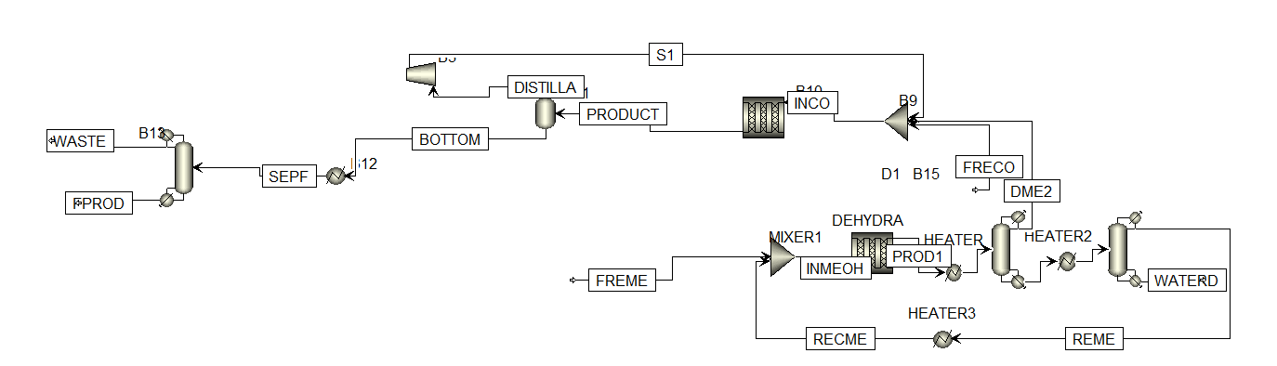*Figure I1: Idealized recycle stream for carbon monoxide**

The idealized PFD included a recycle structure for the carbon monoxide. However, upon simulation, it was found that ASPEN raised mass balance and convergence errors, implying over-specification of the system. Upon further analysis, it was determined that there is some unreacted methane accumulating in the system, which in a continuous process leads to hazards. Hence, in order to have an adequate recycle structure, it is necessary to purge the system off the methane present. However, separation of methane and carbon monoxide is an arduous task, as both the gasses have van-der-waals interactions and are highly non-ideal. Hence, high pressures and low temperatures are required for their separation, which also requires the use of cryogenics as utility fluids. Hence, the cost of adding a recycle outweighs the additional cost of feed required for the process.